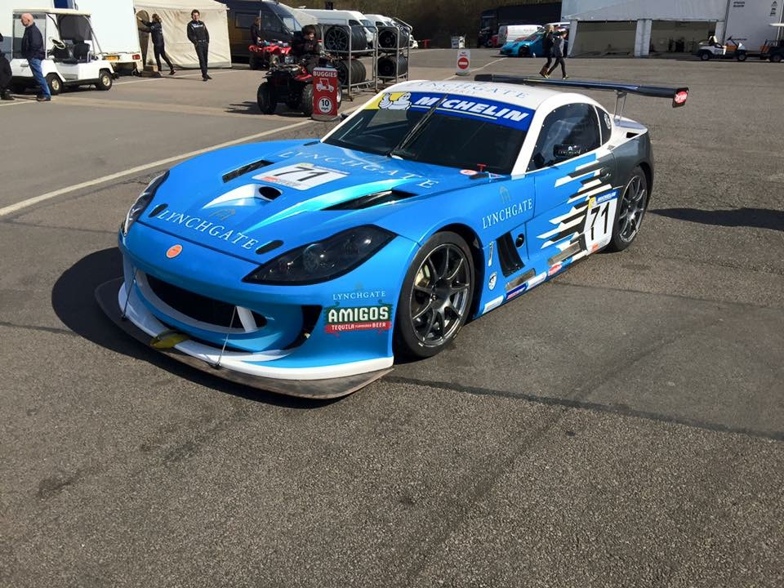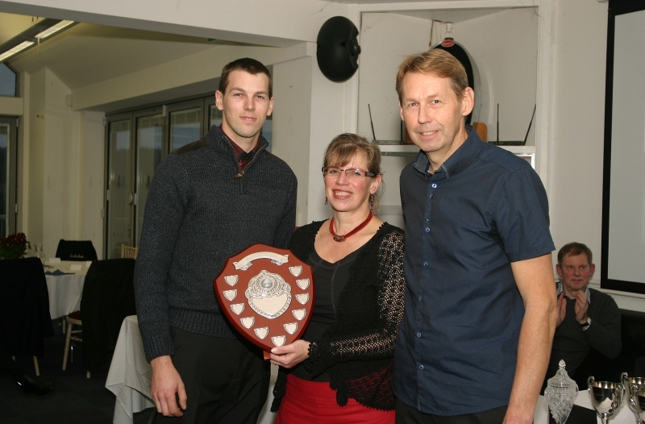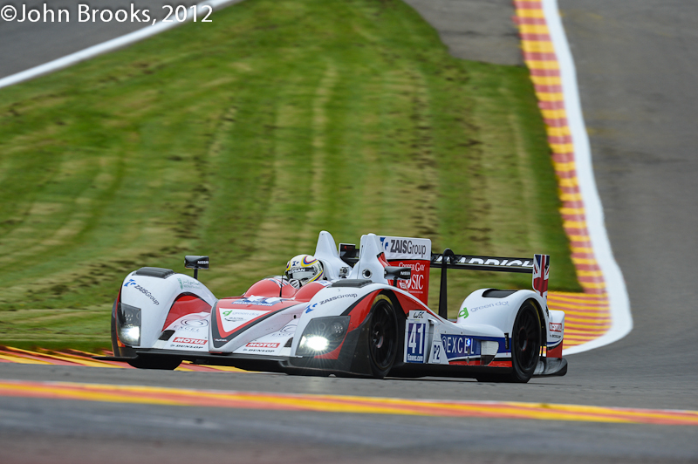

Sprint test and “tuition” day
A pre-season test day with added benefits…..Help and advice from the most successful Motorsport engineer alive today!

Blyton Park – Saturday 11th March 2017
- We are planning a full day of circuit availability for a maximum of 8 cars. The circuit will be open all day for you to get some pre-season testing done, single lap or multi lap runs, for sprinters and hillclimbers to get up to speed for 2107.
- This is not just a “normal” test day though, we will provide access to Go-pro cameras for some of the day (shared between the 8 cars – managed by our staff) and if you provide a 12v feed and earth on your car, we will also fit a simple data logger where possible for some of your runs. The aim of this is to use the video and data to help you improve both your driving technique and car setup. This will be analyzed by Alan Mugglestone, who has taught some of the most successful professional drivers over the past 30 years how to improve…. including F1 champions! For two seater type cars, Alan will also be available to instruct from either the passenger or driver’s seat. This “tuition” will not just be circuit specific, but something you can use to improve your performance everywhere you compete.
- A simple buffet lunch (sandwiches, tea, coffee and cake) will be provided, all included in the price.

Only 8 spaces available, first come first served on a day not to be missed if you want to go faster!
All-inclusive price of £350+VAT per car, - the best value for money you will ever spend for a performance improvement!

Deposit of £200 to secure your place (non refundable, unless we can sell your place to anyone on a reserve list) payable straight away, the remainder to be paid by the 25th of Feb (two weeks before the event).

The event will run, whatever the weather, so you can book with confidence! All levels of competitor welcome, everyone can improve…..

Contact Alan Mugglestone on 07831 299926 – Email : muggo@btinternet.com to reserve your place.
Payment methods will be detailed after the above contact has been made.

